MAIN PAGE
FIBRE CEMENT SIDING & SOFFIT
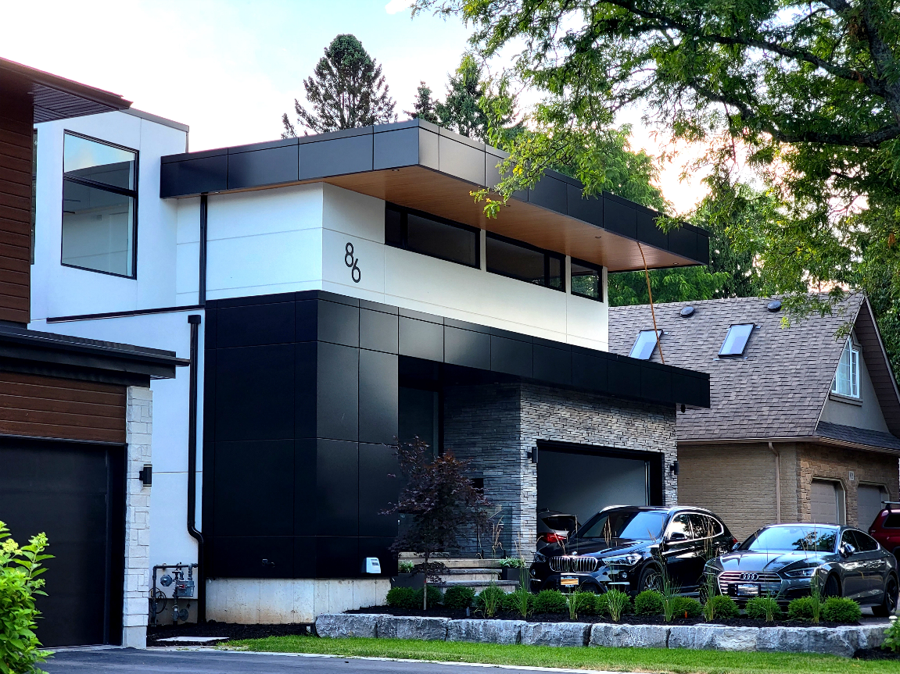
Industrial / Residential / Commercial / Multy-Family / Custom Homes / Hospitality
What Are Fiber Cement Panels?
Fiber cement siding—also known as fiber cement cladding—is a composite material made of cement reinforced with cellulose fibers (replacing asbestos since the 1980s). It's widely used for both residential and commercial exteriors. ...... (Learn More / Expand)
Advantages:
- Durable & low maintenance: Resistant to rot, warping, and pests like termites.
- Fire-resistant: Non-combustible, used in high fire-risk areas.
- Weather-resistant: Engineered to withstand climate extremes, including storms, moisture, and temperature fluctuations.
- Install-friendly: Panels come in sizes that minimize waste and simplify installation, although cutting requires care due to silica dust risks.
- Available in a variety of colors, textures, and profiles, vinyl siding allows for versatile design options to match any architectural style. Its lightweight construction ensures quick and easy installation, providing a high-performance, long-lasting solution for both renovations and new builds.

“Fiber Cement Siding: Design Without Limits, Engineered for Every Climate”
When it comes to fiber cement siding, two industry leaders stand out for their unique strengths: Nichiha, known for “Design Without Limits,” pushes architectural creativity forward with bold textures, rainscreen technology, and finishes that transform both residential and commercial projects into modern statements. On the other hand, James Hardie, trusted worldwide and “Engineered for Every Climate,” delivers unmatched durability and beauty, combining advanced ColorPlus finishes, climate-specific engineering, and strong warranties to ensure performance and curb appeal for decades. Together, they showcase how fiber cement siding can merge style, innovation, and long-term value.

James Hardie Product Overview (EXPANDED)
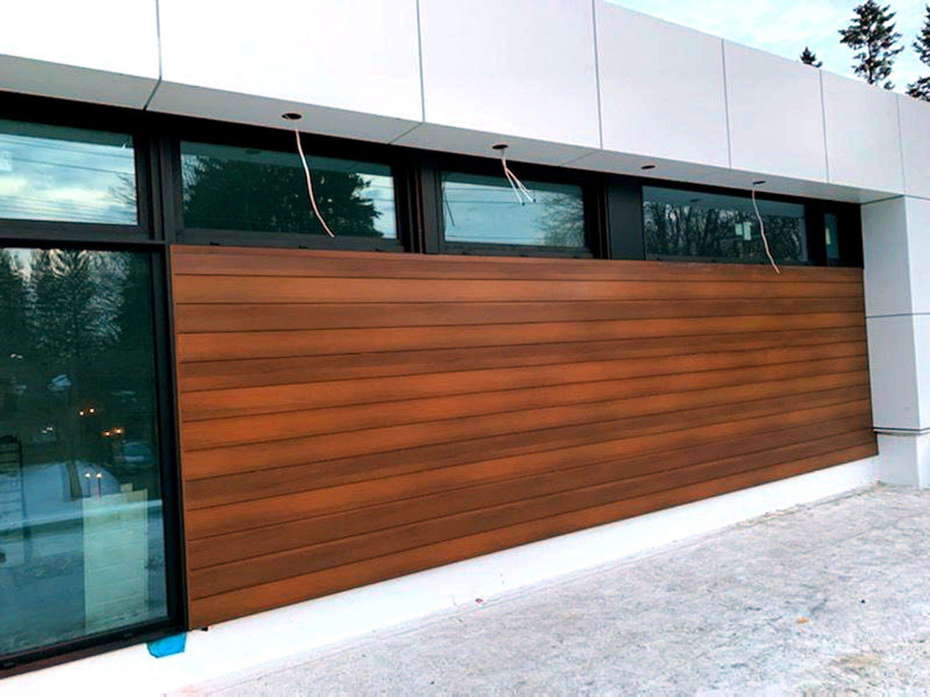
Expanded … Built to Last, Beautifully
James Hardie has earned its reputation as a pioneer in fiber cement technology by focusing on strength, resilience, and aesthetic appeal. Their siding products are crafted to perform under the toughest conditions while offering timeless style, making them a top choice for homeowners, builders, and architects seeking long-lasting beauty.

Applications & Philosophy
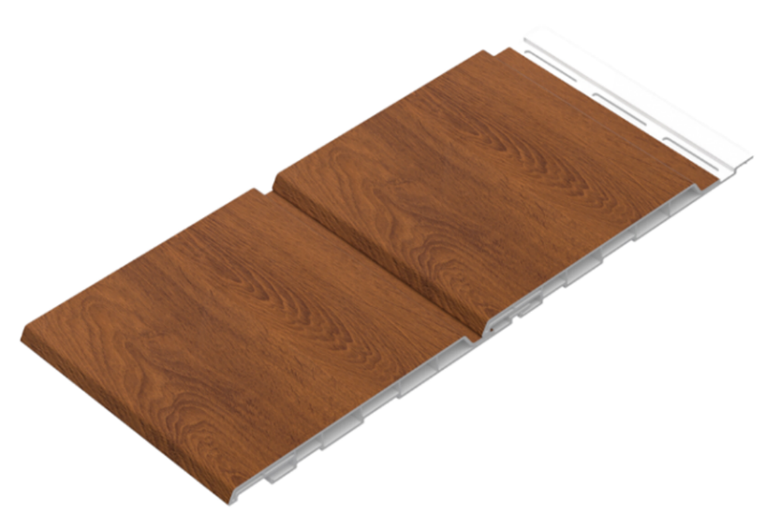

At the core of James Hardie’s approach is their Engineered for Climate® philosophy—each product line is specifically designed to perform in different regional conditions, from harsh northern winters to humid coastal environments. This ensures that every installation maintains its integrity and appearance for years.
The company also emphasizes low-maintenance exteriors, giving property owners peace of mind with siding solutions that resist common problems like rot, warping, and pests. To back their performance claims, James Hardie offers robust, limited 30-year transferable substrate warranties, showcasing their confidence in long-term durability and value.

Technology & Performance
James Hardie siding benefits from ColorPlus® Technology, a factory-applied, baked-on finish that keeps colors vibrant and resists fading, peeling, and chipping far better than traditional paint. The material is also non-combustible and pest-resistant, adding an extra layer of safety and protection for homes and buildings.
Their panels incorporate moisture management features to help prevent mold, mildew, and water damage by keeping walls drier and more secure. Together, these technologies deliver siding solutions that combine safety, efficiency, and standout curb appeal.

Product Choices:

6” Dual-Panel
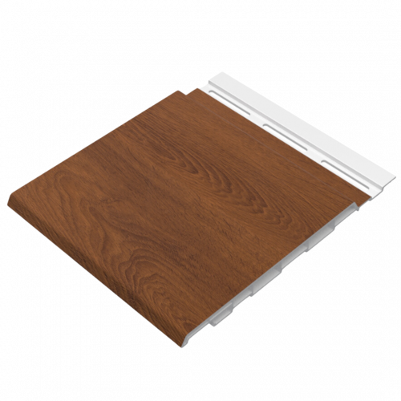

Material: Recycled Rigid PVC
Available Lengths: Solid - 12 ft, 16 ft, 20 ft and 30’, Custom Lengths Available
Profile Dimensions: 6” wide × 0.5” thick
Installation Options: Horizontal and Vertical
Horizontal Siding (Lap, Plank, Artisan)
- Hardie® Plank Lap Siding: Classic and versatile, available in profiles like Select Cedarmill, Smooth, Beaded Select Cedarmill, Beaded Smooth, Custom Colonial Roughsawn, and Custom Colonial Smooth.
- Hardie Artisan Siding Panels: Premium profiles such as V-Groove, Shiplap, Square Channel, and Lap for custom architectural looks. Dimensions typically 144" length, widths from 7.25" to 10.25", thickness about 0.625".

Vertical & Panel Styles
- HardiePanel Vertical Siding: Offered in textures including Select Cedarmill, Smooth, Stucco, and Sierra 8. Sizes range from 16" or 48" widths to lengths of 96"–144", with a thickness around 0.312".
- Hardie Architectural Panel: Contemporary panels with unique textures such as Fine Sand, Mounded Sand, and Sea Grass, 48" wide and lengths of 96"–144".
- Hardie Shingle Siding: Adds character with Straight Edge or Staggered Edge panels, sized 48" long by 15.25" wide and approximately 2.3" thick.

Standard Panels & Accessories
- Smooth primed panels (e.g., 48" × 96", ~0.312" thick) are noncombustible and carry the same climate engineering and warranty as other products. CedarMill and Sierra 8 vertical panels are often chosen for board-and-batten or grooved designs.
- Hardie® Trim Boards come in styles like Rustic Grain, Smooth, and Roughsawn, all with matching ColorPlus finishes and warranty-backed durability for clean, cohesive detailing.
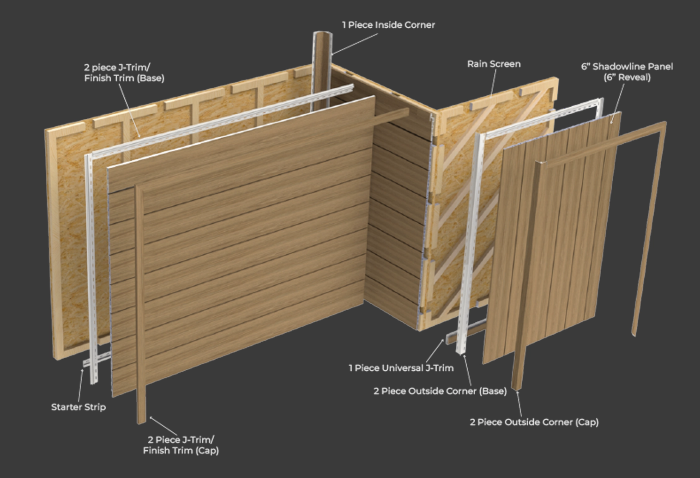

Trims
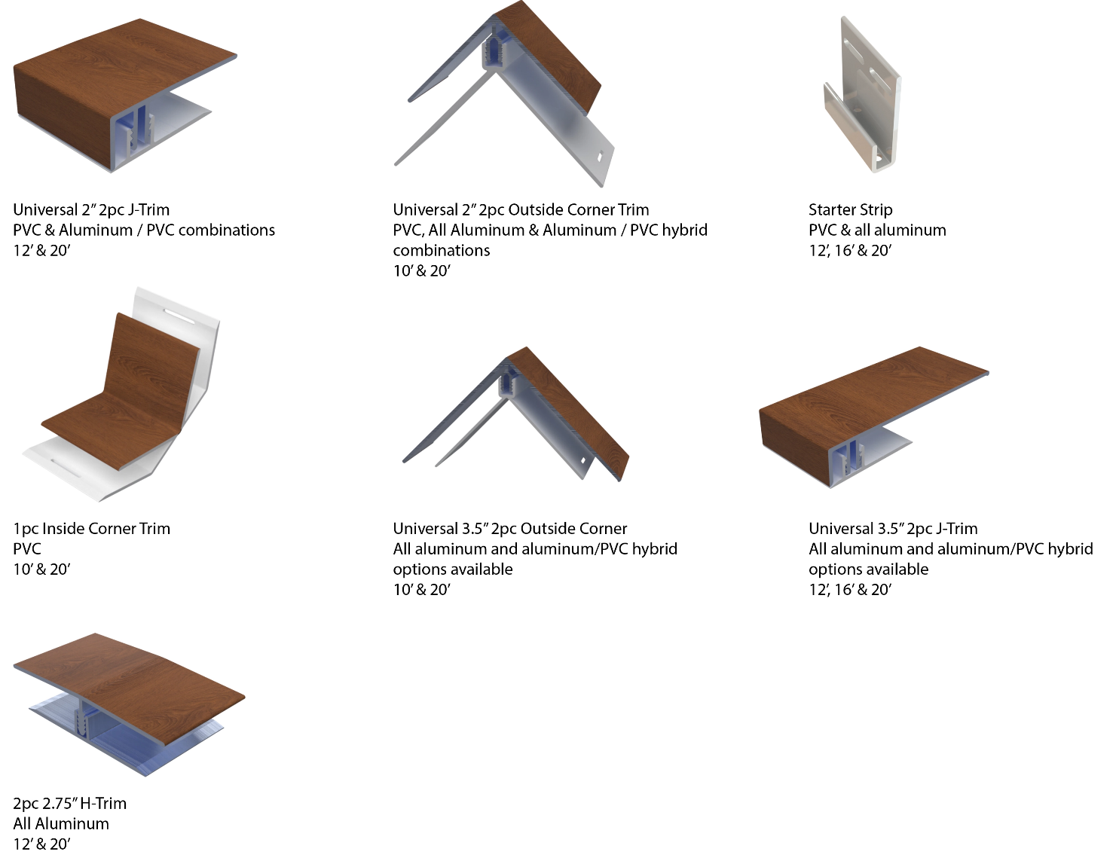

Stunning Finishes That Look and Feel Real
Authentic Textures. Lasting Performance. Designed to Impress.
Our extensive lineup includes rich woodgrains, sleek anodized looks, bold solid tones, metallic sheens, and elegant interior-specific finishes—each developed to meet a wide range of design needs.
Crafted using advanced film technology, many of our finishes feature a high-performance polyvinylidene fluoride (PVDF) top layer. This ensures long-term durability, superior UV resistance, and exceptional colour stability in all environments.
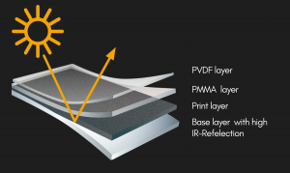
What sets these finishes apart:
- Heat-reflective technology for cooler surfaces and longer lifespan
- Embossed textures that simulate the natural feel of wood and other materials
- High pattern variation to avoid repetition and create a more organic look
- Matte and textured options for modern, high-end aesthetics

Whether you’re designing a modern exterior or an elegant interior feature, CladCan delivers finishes that look as good as they perform.

Looking for something specific?
Get in touch for our full catalogue of available finishes and custom options.

Woodgrain Finishes
6” Dual-Panel

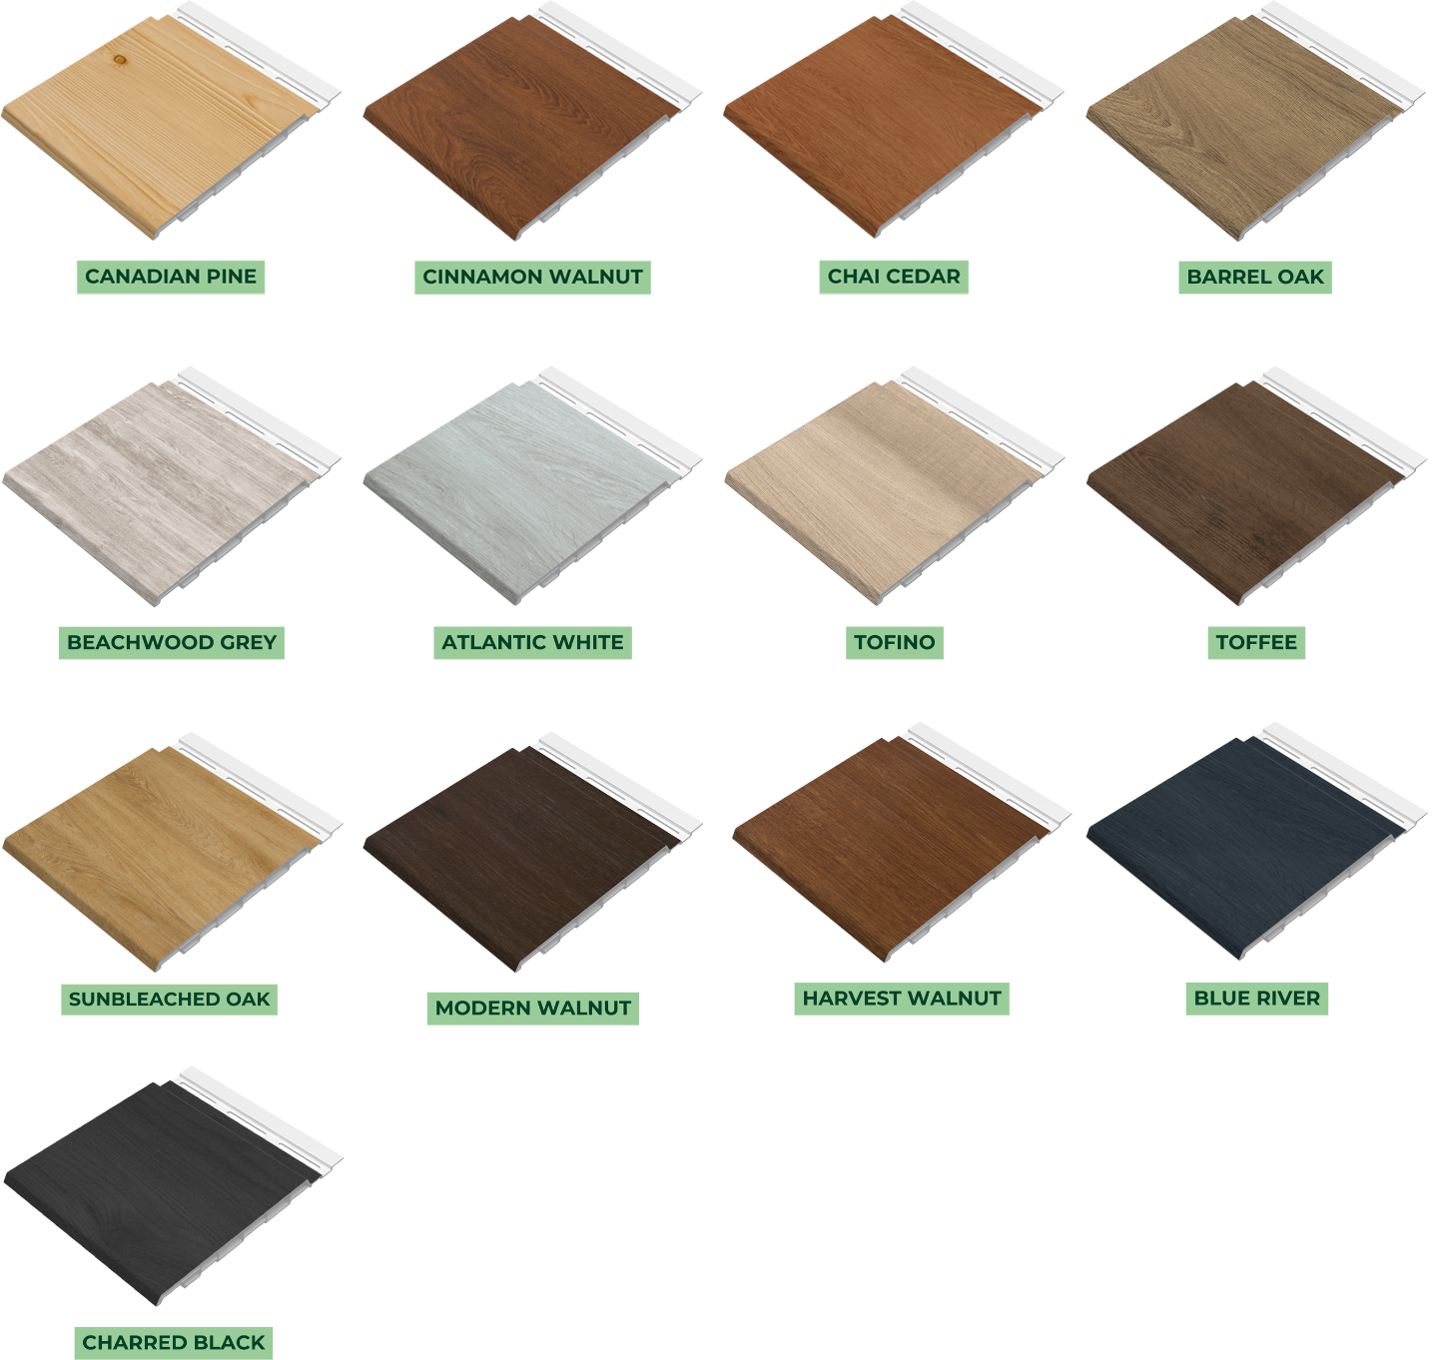

Solid Finishes
6” Dual-Panel

